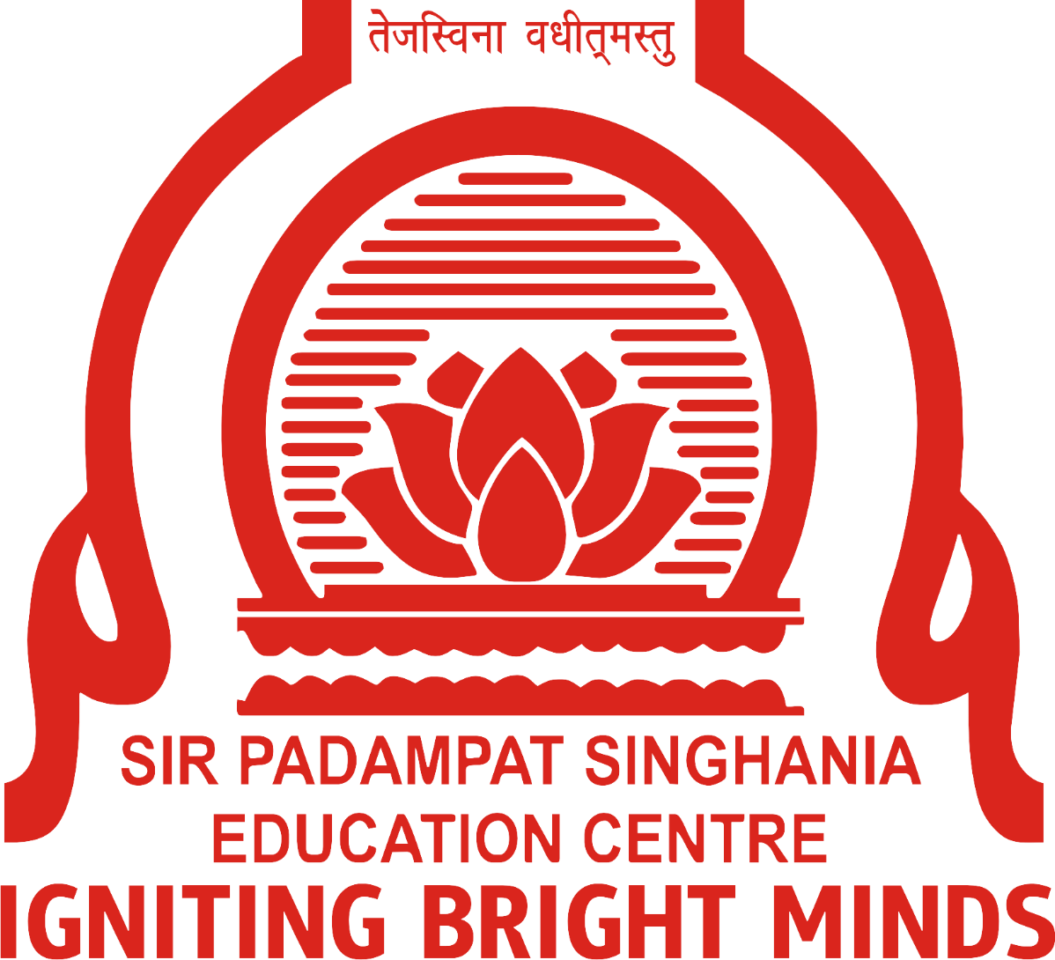  
  
  
**Sir Padampat Singhania Education Centre**

**Kamla Nagar, Kanpur**

**Lesson Plan**

**Session 2023- 2024**

**Class: IX**

**Subject : Chemistry**

**Book : Science (NCERT) - IX**

**Subject Coordinator Head of Department**

Name: A. Dutta Name: Ms. Agnita Naha

Sign: Sign:

**Sir Padampat Singhania Education Centre**

**Kamla Nagar, Kanpur**

**Yearly Syllabus/Planning overview**

**Session: 2023 - 2024**

**Subject: Chemistry**  **Class : 9** **No. of periods: 8**

|  |  |  |  |
| --- | --- | --- | --- |
| **Month** | **Assessed in** | **Lesson/s to be covered** | **Period Count** |
| April | Test 1 | **Chapter 1: Matter in our surroundings** | 8 |
| May | Test 1 | **Chapter 1: Matter in our surroundings** | 5 |
| July | Test 2 | **Chapter 2: Is matter around us pure** | 11 |
| August | Test 2 | **Chapter 2: Is matter around us pure** | 7 |
| September |  | Revision |  |
| October | Test 3 | **Chapter 3: Atoms and molecules** | 9 |
| November | Test 3 | **Chapter 3: Atoms and molecules** | 9 |
| December | Annual Exam | **Chapter 4: Structure of atom** | 11 |
| January | Annual Exam | **Chapter 4: Structure of atom** | 7 |
| February | Annual Exam | Chapter 1, 2, 3 and 4 | 5 |
|  |  |  |  |
|  |  |  |  |
|  |  |  |  |
|  |  |  |  |

Subject coordinator: A. Dutta HOD: Ms. Agnita Naha

**Sir Padampat Singhania Education Centre**

**Kamla Nagar, Kanpur**

**Monthly lesson plan overview**

**Session: 2023 - 2024**

**Subject : Chemistry**  **Class : 9**

**Book : Science (NCERT) - 9** **No. of periods : 8**

|  |  |  |  |  |
| --- | --- | --- | --- | --- |
| **Date/Week** | | **Lesson/s to be covered in classroom** | **Period Count** | **Status (Yes/No)**  **(Reason if No)** |
| **From** | **To** |
| 10.4.23 | 15.4.23 | **Chapter 1: Matter in our surroundings** | 2 |  |
| 17.4.23 | 22.4.23 | **Particulate nature of matter** | 3 |  |
| 24.4.23 | 29.4.23 | **Latent heat** | 3 |  |
| 1.5.23 | 8.5.23 | Intex questions and back exercises | 2 |  |
| 8.5.23 | 13.5.23 | Sublimation and Evaporation | 3 |  |
| 15.5.23 | 21.5.23 | Evaporation (contd) | 3 |  |
| 21.5.23 | 30.5.23 | Back exercises |  |  |
| 1.7.23 | 8.7.23 | Chapter 2: Is matter around us pure | 3 |  |
| 10.7.23 | 15.7.23 | Compounds and mixtures | 3 |  |
| 17.7.23 | 22.7.23 | Solutions | 3 |  |
| 24.7.23 | 31.7.23 | Numericals related to solutions | 2 |  |
| 1.8.23 | 12.8.23 | Colloids, Suspensions | 3 |  |
| 14.8.23 | 19.8.23 | Back exercise + Intro of L- Atoms and molecules | 2 |  |
| 21.8.23 | 26.8.23 | Laws of chemical combination | 2 |  |
| 28.8.23 | 2.9.23 | Intext questions + Atomic mass | 3 |  |
| 4.9.23 | 9.9.23 | Writing Chemical formulae | 3 |  |
| 11.9.23 | 16.9.23 | Writing Chemical formulae | 3 |  |
| 18.9.23 | 24.9.23 | Back exercises + Revision |  |  |
| 26.9.23 | 30.9.23 | Introduction Chapter 4: Structure of atom |  |  |
| 1.10.23 | 7.10.23 | Discovery of electron and proton | 2 |  |
| 9.10.23 | 14.10.23 | Different models of atom | 3 |  |
| 16.10.23 | 21.10.23 | Different models of atom (contd.) | 3 |  |
| 24.10.23 | 31.10.23 | Electronic configuration | 1 |  |
| 1.11.23 | 11.11.23 | Electronic configuration (contd) | 3 |  |
| 13.11.23 | 18.11.23 | Isotopes and Isobars | 2 |  |
| 20.11.23 | 25.11.23 | Back exercise | 2 |  |
| 27.11.23 | 2.12.23 | Back exercises | 2 |  |
| 4.12.23 | 9.12.23 | Revision | 3 |  |
| 11.12.12.23 | 16.12.23 | Practical | 3 |  |
| 18.12.23 | 23.12.23 | Revision | 3 |  |
| 25.12.23 | 30.12.23 | Revision | 2 |  |
| 8.1.24 | 13.1.24 | Revision | 3 |  |
| 15.1.24 | 20.1.24 | Revision | 2 |  |
| 22.1.24 | 27.1.24 | Revision | 2 |  |
| 29.1.24 | 3.2.24 | Revision | 3 |  |
| 5.2.24 | 10.2.24 | Revision | 3 |  |
| 12.2.24 | 17.2.24 | Revision | 2 |  |
| 19.2.24 | 24.2.24 | Revision |  |  |
| 26.2.24 | Onwards | Annual examination |  |  |

Subject coordinator: A. Dutta HOD: Ms. Agnita Naha

**Sir Padampat Singhania Education Centre**

**Kamla Nagar, Kanpur**

**Weekly planning overview**

**Session: 2023- 2024**

**Subject : Biology**

**Class : 9** **No. of periods : 8**

|  |  |  |  |
| --- | --- | --- | --- |
| **Period** | **Topic/s to be covered in classroom** | **Homework** | **Status (Yes/No)**  **(Reason if No)** |
| **WEEK 1:  3.4.23 to 8.4.23 Period Count: 2** | | | |
| PD1 | Interaction with the students |  |  |
| PD2 | Introduction of Chapter 1 |  |  |
| **Note: Second Saturday -8.4.23** | | | |
| **WEEK 2: 10.4.23 to 15.4.23** **Period Count: 2** | | | |
| PD1 | Particulate nature of matter | Read till taught |  |
| PD2 | Particulate nature of matter | Intext Questions/answers |  |
| **Note: Baisakhi and Ambedkar Jayanti - 14 April** | | | |
| **WEEK 3: 17.4.23 to 22.4.23 Period Count: 3** | | | |
| PD1 | Latent heat | Learn the topic taught |  |
| PD2 | Latent heat | Intext ques |  |
| PD3 | Latent heat |  |  |
| **Note : Akhiri Jumma -21.4.23**  **I'd Ul fitr- 22.1.23** | | | |
| **WEEK 4: 25.4.23 to 30.4.23 Period Count: 3** | | | |
| PD1 | Latent heat | Learn the topic taught |  |
| PD2 | Sublimation | Complete the notebook work |  |
| PD3 | Sublimation | Complete the in-text questions/answers |  |
| **WEEK 5.5.23 to 8.5.23 Period Count: 2** | | | |
| PD1 | Evaporation | Do the intext questions |  |
| PD2 | Evaporation | Learn the topic taught |  |
| PD3 | Evaporation | Complete workbook |  |
| **Note: Budhha Purnima - 5.5.23** | | | |
| **WEEK 6: 8.5.23 to 15.5.23 Period Count: 3** | | | |
| PD1 | Intext ques | Do the intext questions |  |
| PD2 | Back exercises | Complete written work of practical notebook |  |
| PD3 | Back exercises | Complete written work of practical notebook |  |
| **WEEK 7-1.7.23 to 8.7.23 Period Count: 2** | | | |
| PD1 | Chapter 2: Is matter around us pure | Read till taught |  |
| PD2 | Elements and compounds | Read till taught |  |
| PD3 | Compounds and mixtures | Read till taught |  |
| **Note :Second Saturday- 8.7.23** | | | |
| **WEEK 8 -10.7.23 to 15.7.23 Period Count: 3** | | | |
| PD1 | Compounds and mixtures | Read till taught |  |
| PD2 | solutions | Read till taught |  |
| PD3 | Solutions | Read till taught |  |
| **WEEK 9-17.7.23 to 22.7.23 Period Count: 3** | | | |
| PD1 | Numericals related to solutions | Solve numericals |  |
| PD2 | Numericals related to solutions | Practice numericals |  |
| PD3 | Suspensions | Read till taught |  |
| **WEEK 10-24.7.23 to 31.7.23 Period Count: 2** | | | |
| PD1 | Colloids | Read till taught |  |
| PD2 | Intext ques | Intex questions to be done in the notebook |  |
| PD3 | Back exercises discussed | Back questions to be done in the notebook |  |
| **Note: Moharram - 29.7.23** | | | |
| **WEEK 11-1.8.23 to 12.8.23 Period Count: 2** | | | |
| PD1 | Chapter 3: Atoms and Molecules | Read till taught |  |
| PD2 | Laws of Chemical Combination | Read till taught |  |
| PD3 | Laws of Chemical Combination | Read till taught |  |
| **Note - Second Saturday - 12.8.23** | | | |
| **WEEK 12- 14.8.23 to 19.8.23 Period Count: 3** | | | |
| PD1 | Atomic mass | Read till taught |  |
| PD2 | Atomic mass | Read till taught |  |
| PD3 | Writing Chemical Formulae | Learn valencies |  |
| **Note- Independence day - 15.8.23** | | | |
| **WEEK 13 -21.8.23 to 26 .8.23 Period Count: 3** | | | |
| PD1 | Writing Chemical Formulae | Learn valencies |  |
| PD2 | Writing Chemical Formulae | Practice questions |  |
| PD3 | Isobars and isotopes | Questions |  |
| **WEEK -14:28.8.23 to 2.9.23 Period Count: 2** | | | |
| PD1 | Back exercises | Complete written work |  |
| PD2 | Revision: Is matter around us pure | Learn and prepare Chapter 2 |  |
| PD3 | Revision: Is matter around us pure | Learn and prepare Chapter 2 |  |
| **Note- Rakshabandhan - 31.8.23** | | | |
| **WEEK -15.9.23 to 9.9.23 Period Count: 2** | | | |
| PD1 | Revision : Atoms and molecules | Learn and prepare Chapter 3 |  |
| PD2 | Revision : Atoms and molecules | Learn and prepare Chapter 3 |  |
| PD3 | Revision : Atoms and molecules | Learn and prepare Chapter 3 |  |
| **Note- Janamasthi Holiday - 9.9.23** | | | |
| **WEEK 16 -11.9.23 to 16.9.23 Period Count: 3** | | | |
| PD1 | Chapter 4: Structure of atom | Read till taught |  |
| PD2 | Discovery of electron | Read till taught |  |
| PD3 | Discovery of proton | Read till taught |  |
| **WEEK 17:18.9.23 to 24.9.23 Period Count: 3** | | | |
| PD1 | Diff models of atom | Read till taught |  |
| PD2 | Diff models of atom | Read till taught |  |
| PD3 | Diff models of atom | Read till taught |  |
| **WEEK 18:-26.9.23 to 30.9.23 Period Count: 3** | | | |
| PD1 | Diff models of atom | Read till taught |  |
| PD2 | Diff models of atom | Read till taught |  |
| PD3 | Electronic configuration | Read till taught |  |
| **WEEK 19:-1.10.23 to 7.10.23 Period Count: 2** | | | |
| PD1 | Electronic configuration | Read till taught |  |
| PD2 | Electronic configuration | Practice questions |  |
| PD3 | Electronic configuration | Read till taught |  |
| **Note- Gandhi Jayanti - 2.10.23** | | | |
| **WEEK 20:-9.10.23 to 14.10.23 Period Count: 2** | | | |
| PD1 | Intext questions | Read till taught |  |
| PD2 | Isotopes and Isobars | Read till taught |  |
| PD3 | Isotopes and Isobars | Complete the chart |  |
| **Note - Second Saturday -14.10.23** | | | |
| **WEEK 21:- 16.10.23 to 21.10.23 Period Count: 3** | | | |
| PD1 | Back exercises | Back exercises to be done in notebook |  |
| PD2 | Intext questions | In-text questions to be done in notebook |  |
| PD3 | Revision: Structure of atom | Learn |  |
| **WEEK 22:-24.10.23 to 31.10.23 Period Count: 1** | | | |
| PD1 | Revision: Structure of atom | Learn |  |
| PD2 | Revision: Structure of atom | Learn |  |
| PD3 | Revision: Structure of atom | Learn |  |
| **Note - 22.10.23 to 24.10.23 - Asthami, Navmi, Dusshera**  **Valmiki Jayanti- 28.10.23** | | | |
| **WEEK 23:- 1.11.23 to 11.11.23 Period Count: 3** | | | |
| PD1 | Practical | Complete lab manual |  |
| PD2 | Practical | Complete lab manual |  |
| PD3 | Practical | Complete lab manual |  |
| **WEEK 24:- 13.11.23 to 18.11.23 Period Count: 2** | | | |
| PD1 | Revision | Learn |  |
| PD2 | Revision | Learn |  |
| PD3 | Revision | Learn |  |
| **Note- Deepawali Holidays - 10.11.23 to 14.11.23** | | | |
| **WEEK 25:-20.11.23 to 25.11.23 Period Count: 2** | | | |
| PD1 | Revision | Learn |  |
| PD2 | Revision | Learn |  |
| PD3 | Revision | Learn |  |
| **Note- Guru Tej Bahadur Balidan Diwas- 24.11.23** | | | |
| **WEEK 26:-27.11.23 to 2.12.23 Period Count: 2** | | | |
| PD1 | Revision | Learn |  |
| PD2 | Revision | Learn |  |
| PD3 | Revision | Learn |  |
| **Note- Gurunanak Jayanti - 27.11.23** | | | |
| **WEEK 27:-4.12.23 to 9.12.23 Period Count: 2** | | | |
| PD1 | Revision | Learn |  |
| PD2 | Revision | Learn |  |
| **Note - Second Saturday - 9.12.23** | | | |
| PD3 | Revision | Learn |  |
| **WEEK 28:-11.12.23 to 16.12.23 Period Count: 3** | | | |
| PD1 | Revision | Learn |  |
| PD2 | Revision | Learn |  |
| PD3 | Revision | Learn |  |
| **WEEK 29:-18.12.23 to 23.12.23 Period Count: 3** | | | |
| PD1 | Revision | Learn |  |
| PD2 | Revision | Learn |  |
| PD3 | Revision | Learn |  |
| **WEEK 30:-25.12.23 to 30.12.23 Period Count: 2** | | | |
| PD1 | Revision | Learn |  |
| PD2 | Revision | Learn |  |
| PD3 | Revision | Learn |  |
| **Note- Christmas Day- 25.12.23** | | | |
| **WEEK 31:-8.1.24 to 13.1.24 Period Count: 3** | | | |
| PD1 | Revision | Learn |  |
| PD2 | Revision | Learn |  |
| PD3 | Revision | Learn |  |
| **WEEK 32:-15.1.24 to 20.1.24 Period Count: 2** | | | |
| PD1 | Revision | Learn |  |
| PD2 | Revision | Learn |  |
| PD3 | Revision | Learn |  |
| **Note- Makar sankranti - 15.1.24**  **Guru Govind Singh Jayanti - 17.1.24** | | | |
| **WEEK 33:-22.1.24 to 27.1.24 Period Count: 2** | | | |
| PD1 | Revision | Learn |  |
| PD2 | Revision | Learn |  |
| PD3 | Revision | Learn |  |
| **Note- Republic Day - 26.1.24** | | | |
| **WEEK 34:-29.1.24 to 3.2.24 Period Count: 3** | | | |
| PD1 | Revision | Learn |  |
| PD2 | Revision | Learn |  |
| PD3 | Revision | Learn |  |
| **WEEK 35:-5.2.24 to 10.2.24 Period Count: 2** | | | |
| PD1 | Workbook | Learn |  |
| PD2 | Workbook | Learn |  |
| PD3 | Revision | Revision questions to be done in the notebook |  |
| **Note- Second Saturday - 10.2.24** | | | |
| **WEEK 36:-12.2.24 to 17.2.24 Period Count: 2** | | | |
| PD1 | Revision | Revision questions to be done in the notebook |  |
| PD2 | Revision | Revision questions to be done in the noteboo |  |
| PD3 | Revision | Revision questions to be done in the notebook |  |
| **Note- Basant Panchami - 14.2.24** | | | |
| **WEEK 37:-19.2.24 to 24.2.24 Period Count: 2** | | | |
| PD1 | Revision | Learn and prepare |  |
| PD2 | Doubt clearance | Learn and prepare |  |
| PD3 | Doubt clearance | Learn and prepare |  |
| **Note- Ravi Das Jayanti -24.2.24** | | | |
| **WEEK 38- 26.2.24** | | | |
|  | Annual Exams |  |  |
|  | | | |

Subject coordinator: A. Dutta HOD: Ms. Agnita Naha